**Recognized pattern form：Gumen_variety1**

**The name of the identified app：Xmp for Android**

**Corresponding to the name of APP in sample：**

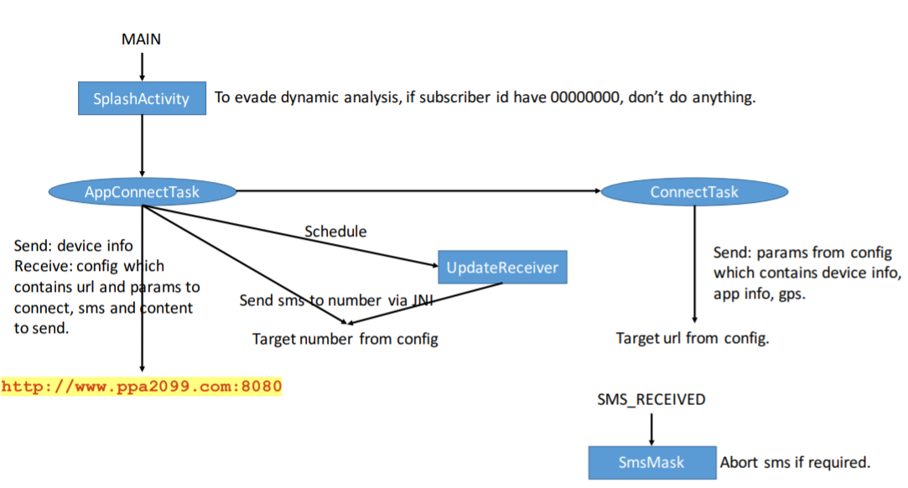

**For functions in sample app:：**

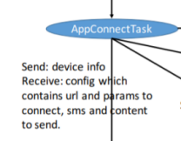

**Corresponding to the key code of the identified app:**

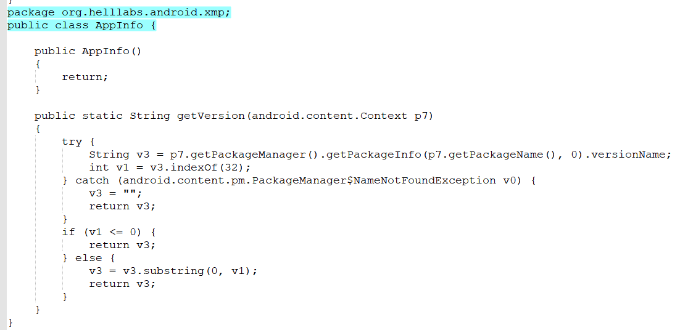

**Corresponding to the key code in sample app:**

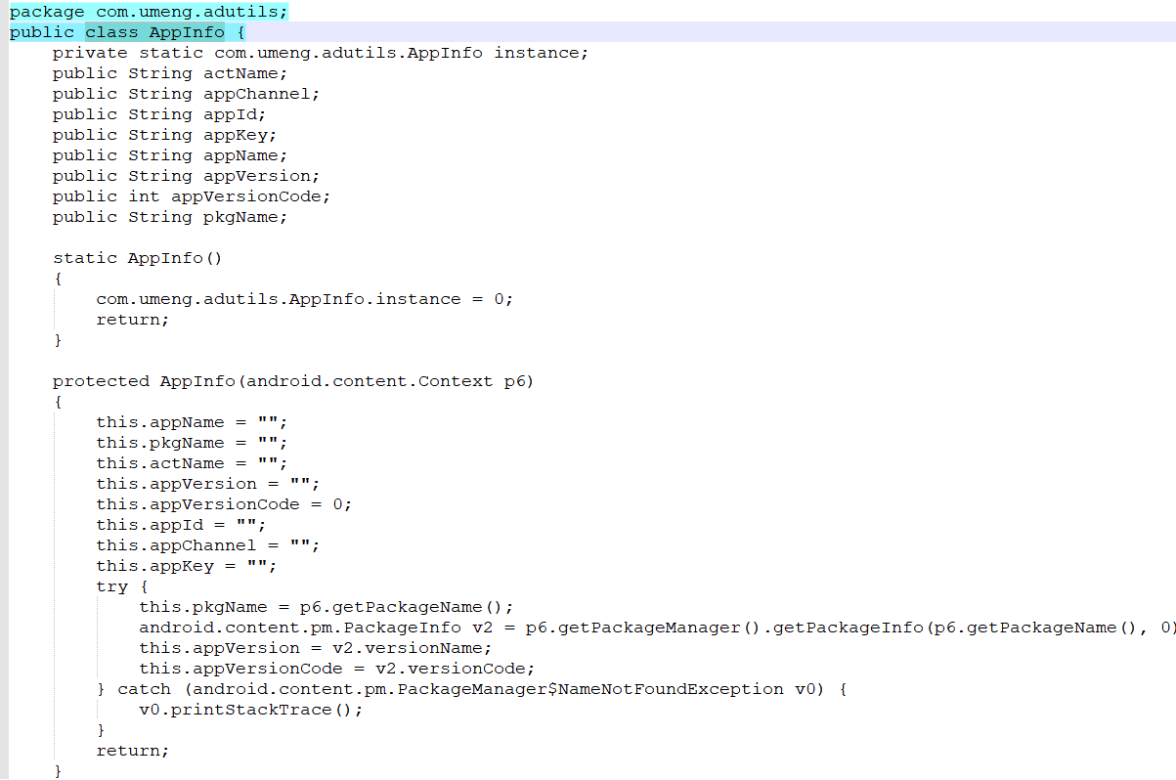

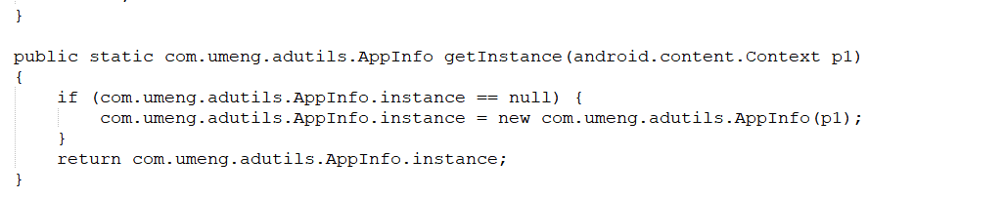

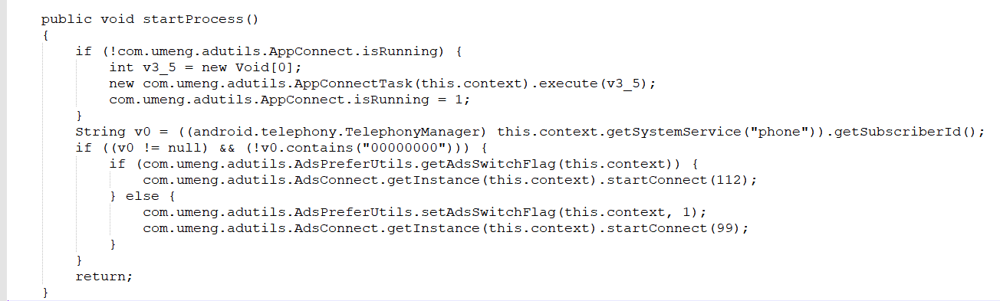

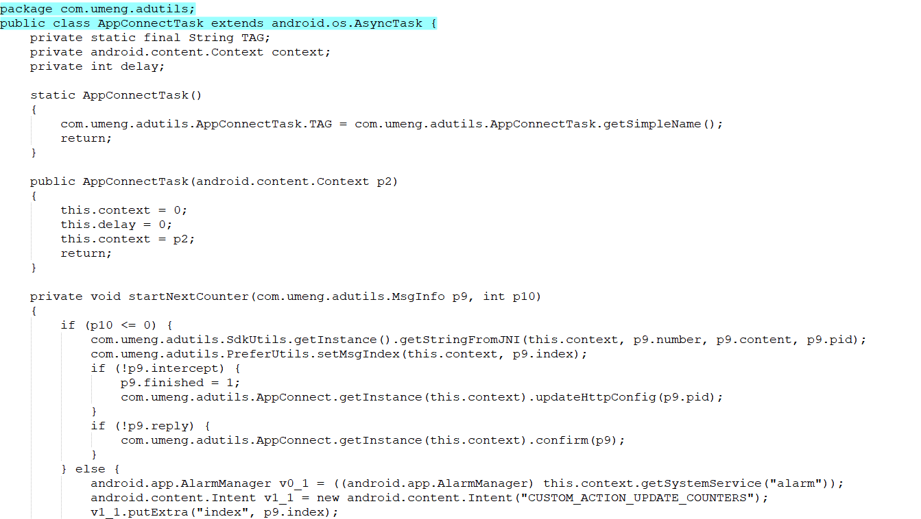

Corresponding to the key code in this app:

